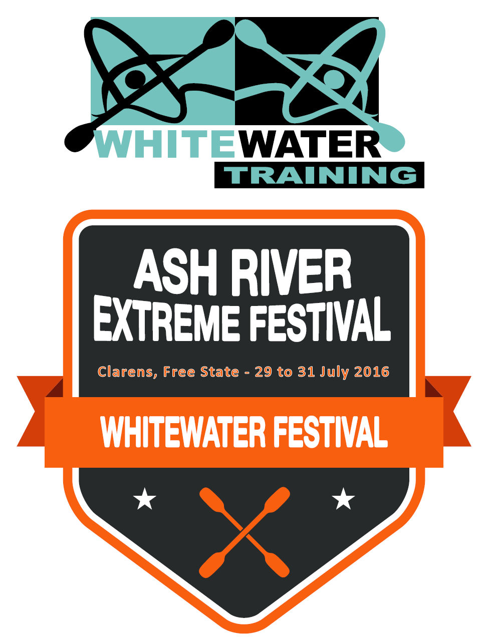
It’s that time of the year again.
Here are details to bear in mind when completing the entry form:
- As usual, we will have a commemorative item for Ash-Fest 2016. This time it’s a scarf. These memorabilia will be given on a “first come, first served” basis, if you enter late, you may not receive one.
- The entry for Ash Fest 2016 is once again R300 regardless of your chosen craft. There’s no extra charge if you choose more than one craft. See banking details below:
Whitewater Training,
First National Bank.
Branch – Parys, 230 736
Account # – 51081140480
- Send proof of payment to wwt@whitewatertraining.co.za and use your name plus what the payment is for (for example J Smith – Ash fest) as reference.
- You’ll need to arrange your own accommodation. This year we will once again be staying at the Clarens Inn and Backpackers. Email clarensinn@gmail.com for details.
- Remember to bring your own food, drinks, cutlery etc., toiletries, tent (if camping) etc. This is a self-catering event!
- Complete one entry form per person.
- Everyone must have a signed indemnity form on the day. Please download and complete the Indemnity and present it to us at the ASH-fest 2016.
(INDEMNITY)
ASH-FEST 2016
‘NEED TO KNOw’
Don’t miss out on our annual paddling festival on the
Ash River.
What’s New in 2016?
- This year we will include a rafting category, so gather your team and get ready to show us what you can do in an inflatable.
What’s the Same?
- We will once again be partying on the Saturday night so prepare accordingly.
- In fine ASH-Fest tradition, we will also be acknowledging efforts made to grow the finest moustache in paddler-land.
- Non-competitors can enjoy the river on the Sunday Social Paddle

Whitewater Training
34 Boom Street, Parys
P.O. Box 332, Parys, 9585
Tel (056) 811 2597
www.whitewatertraining.co.za
wwt@whitewatertraining.co.za
ENTRY FORM
(Complete and return to Whitewater Training with proof of payment. One form per participant)
PERSONAL DETAILS
First name
Last name
Telephone number
Email address
ID number
Which category/ies will you compete in?  (Mark with an X all that apply) | Rafting |  | SUP |  | Kayaking
 | Beginner |  | Junior |  | Intermediate |  | Expert
 | All experts must have the required equipment when doing Safety or Racing. Have a look at the link for the correct compulsory Gear list, follow the link and check that you have everything – Compulsory GEAR LIST for experts only!
 | Male |  | Female
Safety/Rescue Training completed | Course
 | Dates
Safety/Rescue Equipment
Canoe SA number (Optional)
Will you join the Sunday Social Paddle at R100 per person (you don’t need to pay this if you entered for the events) | Yes |  | No
MEDICAL DETAILS
Medical conditions & health
Medical Aid Membership:
Medical Aid Number:
Telephone no. of next of kin
Relationship
Which region are you from?

